# **Title [Title Case; Bold; Calibri Light; Font Size 14; max 2 Lines] Template and Guideline** for Abstract Submission

**Irène Joliot-Curie1 and Michael Faraday2 (Please underline presenter)**

1Contact details: affiliation, address and e-mail address of presenting author.

2Other author’s contact details, each placed in a separate line, without e-mail address.

The abstract should not exceed 1 page, including images and reference list. This document serves both as a guideline and a template for preparing your abstract for the 5th International Conference on Electrolysis. To format your abstract correctly, please use the predefined word styles defined in this document (e.g. text body in Calibri font size 11 pt.). The abstract should follow the rough structure: (short) introduction, the scope of the work, methodology, results, and references. Use paragraphs to make the structure clear. All figures, tables, and references should be cited in the text, see Figure 1, and embedded in the text, as in the following example.

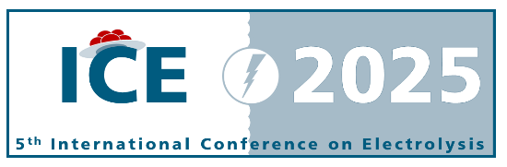

Figure 1: Captions (font size 9 pt.) should be centered and placed below the figure.

Your abstract should be able to convince the review panel of its significance successfully. Review criteria cover (1.) Relevance to the conference topics; (2.) Originality and interest to the participants; (3.) Scientific quality of the methodology and results; and (4.) Formalities and clarity of the abstract. Depending on the evaluation of your abstract, you may be invited to present a poster or have an oral presentation at the conference. Each manuscript has to be uploaded as .pdf file to the ICE 2025 platform (https://event.fourwaves.com/ice2025). The pdf should be named ICE2025_[Last name]_[First name] e.g. ICE2025_Joliot-Curie_Irene.

References should be numbered consecutively throughout the text and collected in a bibliographic list at the end of the paper following the style in font size 9:

[1] W.R. Groove: Address To The British Association For The Advancement Of Science. London (1867), Longmans, Green & Co

[2] T. A. Zawodzinski Jr. et al (1993) J. Electrochem. Soc. 140 1041, DOI 10.1149/1.2056194